***Software Development Assignment***

**Contents**

1. Page 2 – User Guide.
2. Page 3 – Design and Details. (Pseudo Code & Diagram)
3. Page 4– Test Procedure.

Ryan Monaghan

Software development– C20054

11/12/2013

***User Guide***

The Scientific Calculator is relatively easy to use. The following steps will guide you through the functionality of the Calculator:

* 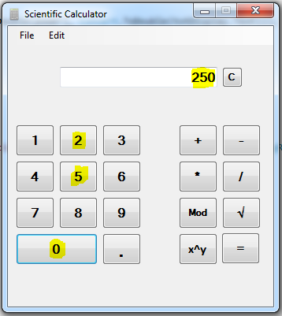1. Firstly select your first input, simply browse the number buttons shown, and select the value you would like to enter. Once you have selected your input, the numbers should be displayed on screen. (For e.g. we have selected the Number 250 using the number buttons, and it has displayed in the text box.)
* 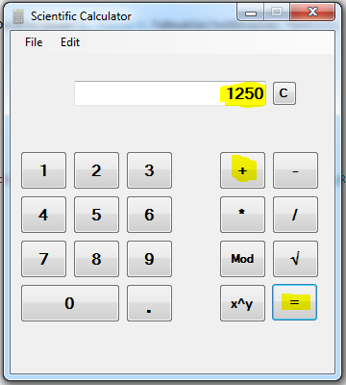2. After entering your firs input, you then need to decide which operator you would like to apply to this value, would you like to add, subtract, divide, multiply, mod, square root, or raise your value to a power? Once you have selected an operator, you will need to click the equal’s button to display the result. (Continuing on from the previous example, we have chosen to add 1000 to our selected value, 250, once we press the “+” button, our value is stored, and will then be displayed as an answer once the “=” button is pressed.)
* 3. If a mistake is made during your input, you can clear the textbox by simply pressing the “C” button, next to the text box.
* 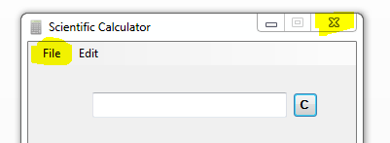4. Te menu buttons along the upper part of the application supply a number of options. You may close the application by clicking on the red close arrow, or alternativly by File < Quit < Ok.

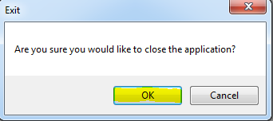

Ryan Monaghan

Software development– C20054

11/12/2013

***Pseudo Code***

1. A button is pressed and a corresponding input is placed into the display box.
2. The user then selects an operator.
3. The operator stores the users input from step 1.
4. The user then clicks the “=” button.
5. Once the “=” button is pressed, it applies the mathematical operator, or operation selected.
6. And finally displays the answer in the text box.

Input 1

Operator stores value and operation symbol

Answer displayed on txtDisplay.

Input 2

theOperator = “x^x”

theOperator = “Mod”

theOperator = “/”

theOperator = “*”

theOperator = “-”

theOperator = “+”

Switch (theOperator)

btnEquals_Clicked

Ryan Monaghan

Software development– C20054

11/12/2013

***Test Procedure***

|  |  |  |  |  |  |
| --- | --- | --- | --- | --- | --- |
| Test Case ID | Test Run | Expected Result | Actual Result | Test Accuracy | Pass/Fail |
| 1. | 5+5 | 10 | 10 | 100% | Pass |
| 2. | 5-5 | 0 | 0 | 100% | Pass |
| 3. | 2.7*9.8 | 24.5 | 24.5 | 100% | Pass |
| 4. | 98Mod10 | 8 | 8 | 100% | Pass |
| 5.  6.  7.  8.  9.  10.  12.  13.  14.  15.  16.  17.  18.  19.  20.  21.  22.  23.  24.  25.  26.  27.  28.  29.  30. | Sqrt100  Sqrt55  40Mod4.5  7*85  2^2  5^5  64/8  45*7  22Mod7  2+89  5Mod10  4.67-2  Sqrt200  7*89  2Mod1  100/0  Sqrt90  2-3  3^3  5/2  100/8  3*8  8+6  100*11  6^6 | 10  7.4161  0  595  4  3125  8  315  1  91  5  2.67  14.142  623  0  Error “Tried to divide by Zero”  9.486  -1  27  2.5  12.5  24  14  1100  7776 | 10  7.4161  0  595  4  3125  8  315  1  91  5  2.67  14.142  623  0  Error “Tried to divide by Zero”  9.486  -1  27  2.5  12.5  24  14  1100  7776 | 100%  100%  100%  100%  100%  100%  100%  100%  100%  100%  100%  100%  100%  100%  100%  100%  100%  100%  100%  100%  100%  100%  100%  100%  100% | Pass  Pass  Pass  Pass  Pass  Pass  Pass  Pass  Pass  Pass  Pass  Pass  Pass  Pass  Pass  Pass  Pass  Pass  Pass  Pass  Pass  Pass  Pass  Pass  Pass |

Ryan Monaghan

Softwaredevelopment– C20054

11/12/2013